**LAB EXERCISE – 4**

**(GROUPS)**

**1. How many different departments are there in the ‘employee’ table?**

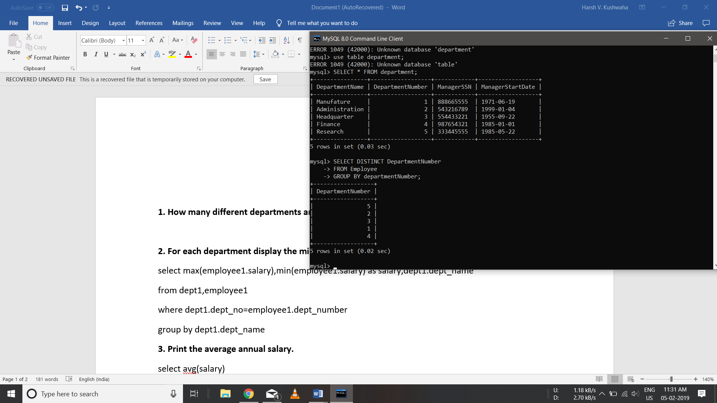

**2. For each department display the minimum and maximum employee salaries.**

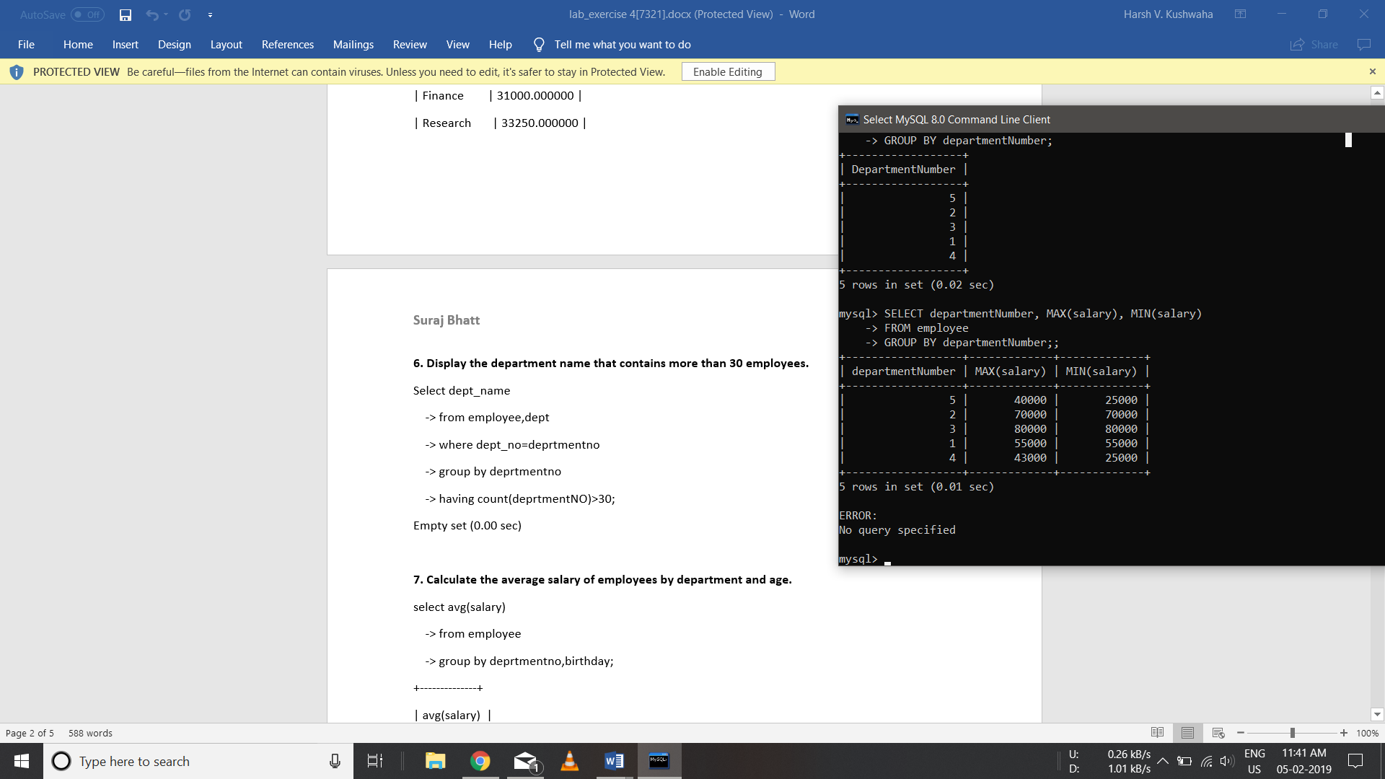

**3. Print the average annual salary.**

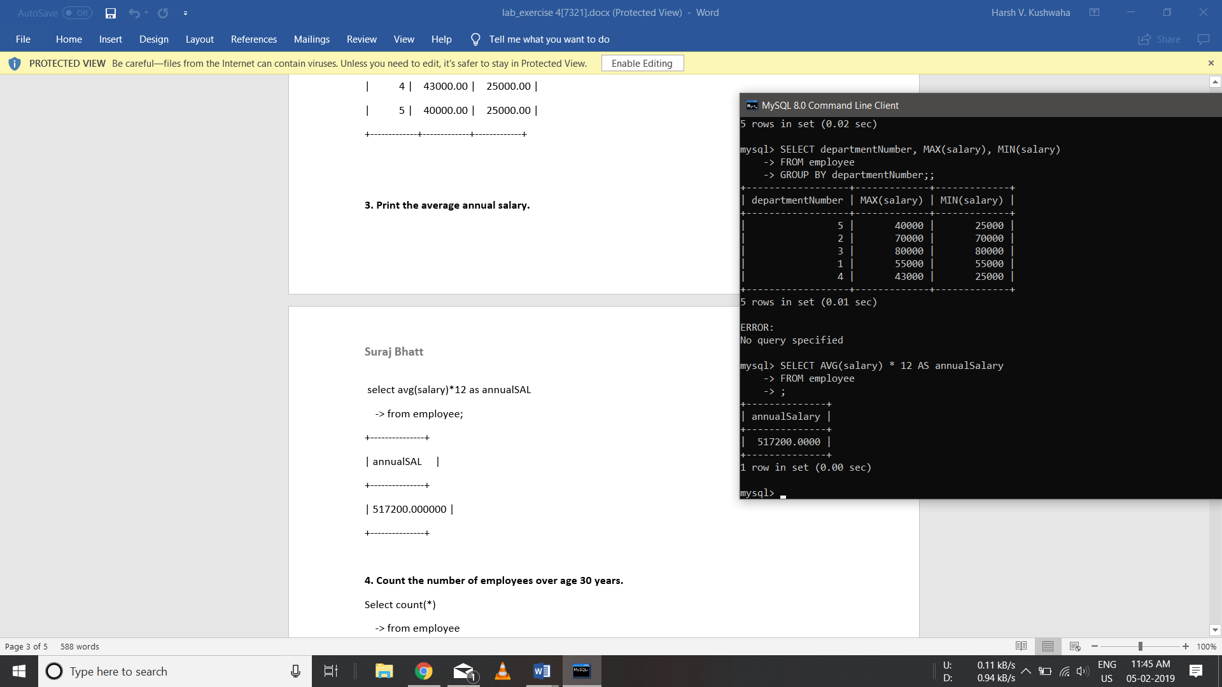

**4. Count the number of employees over age 30 years.**

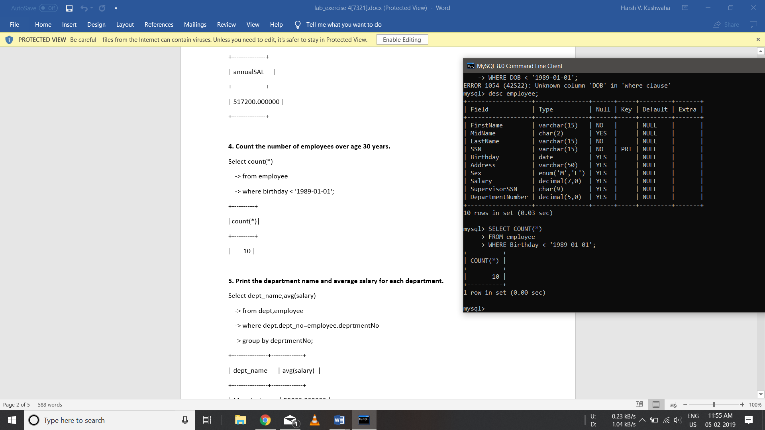

**5. Print the department name and average salary for each department.**

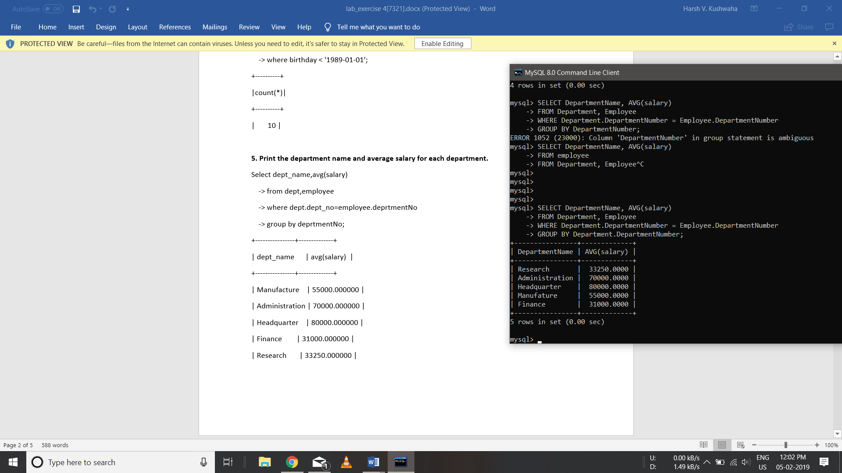

**6. Display the department name that contains more than 30 employees.**

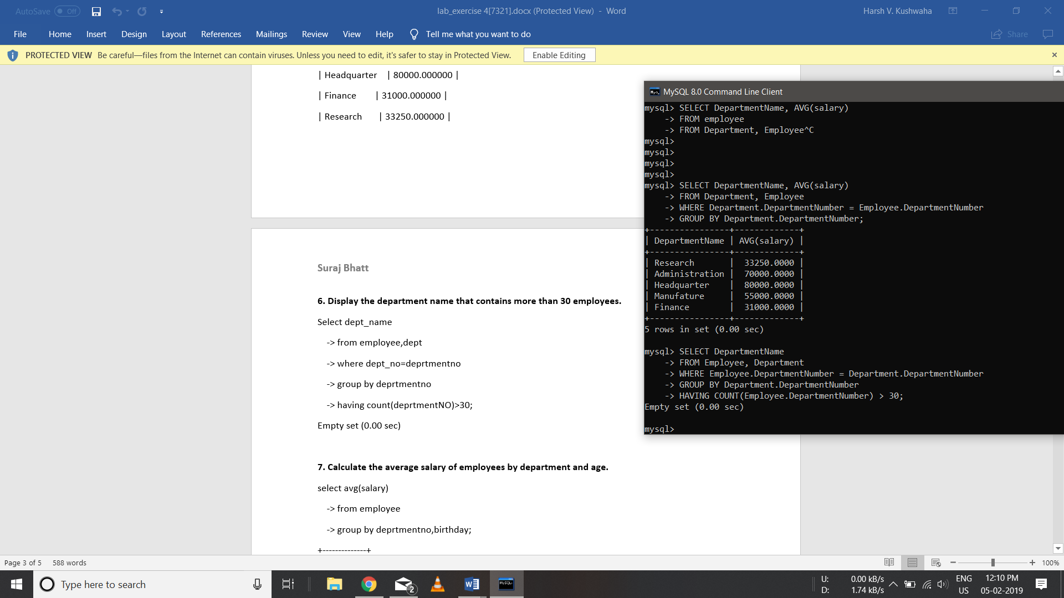

**7. Calculate the average salary of employees by department and age.**

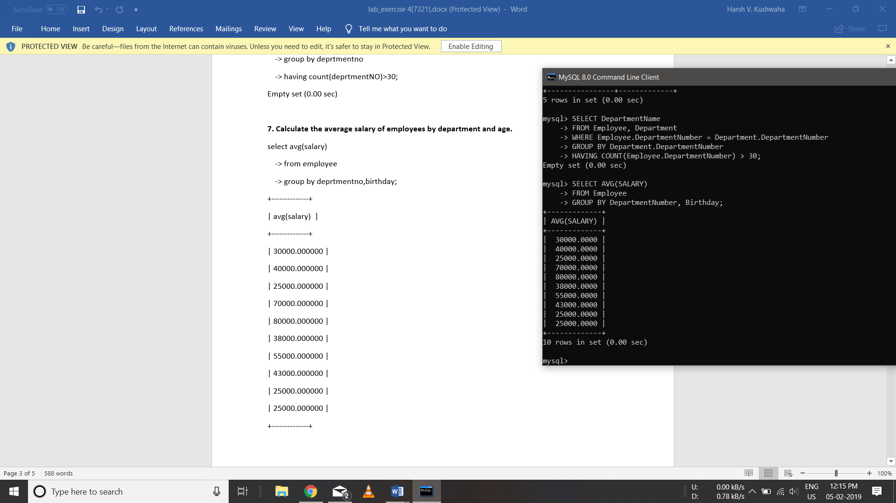

**8. Calculate the number of employees in finance and research department.**

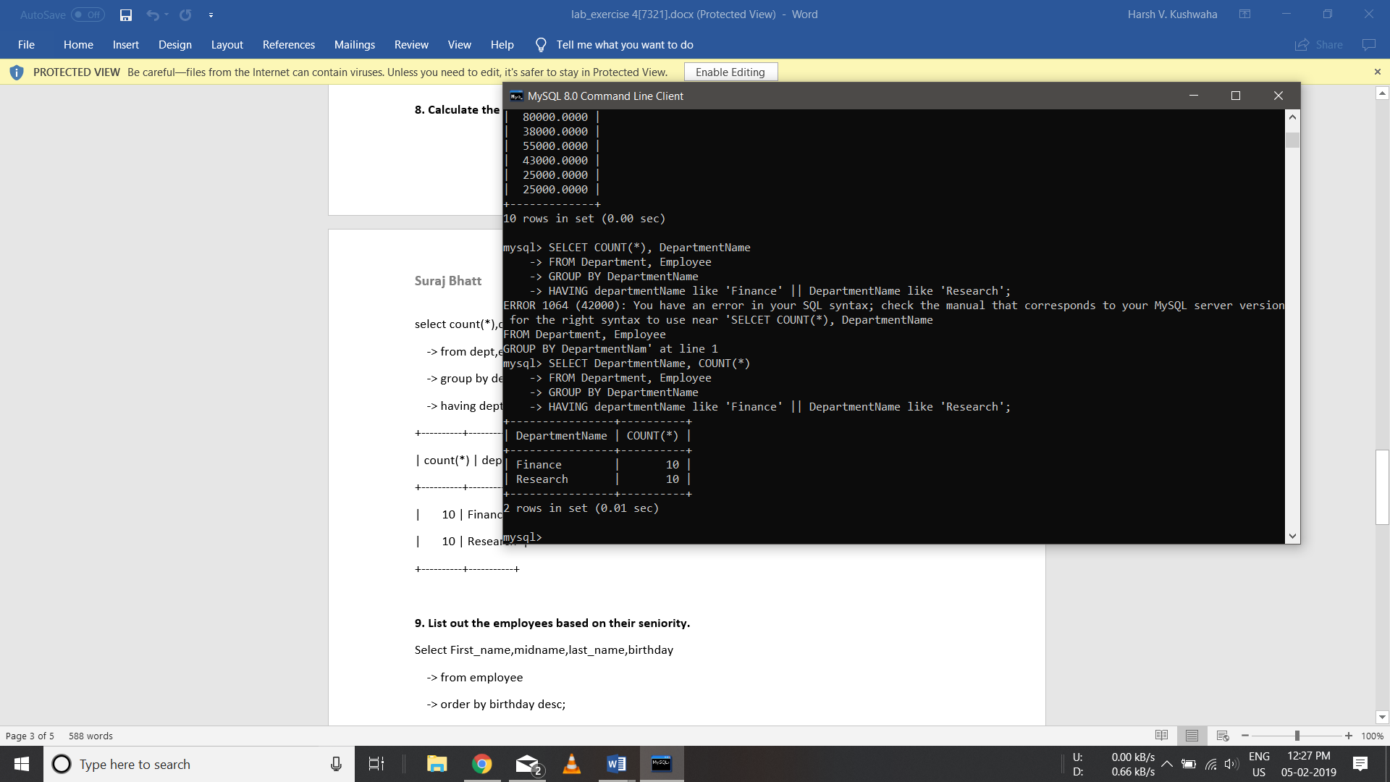

**9. List out the employees based on their seniority.**

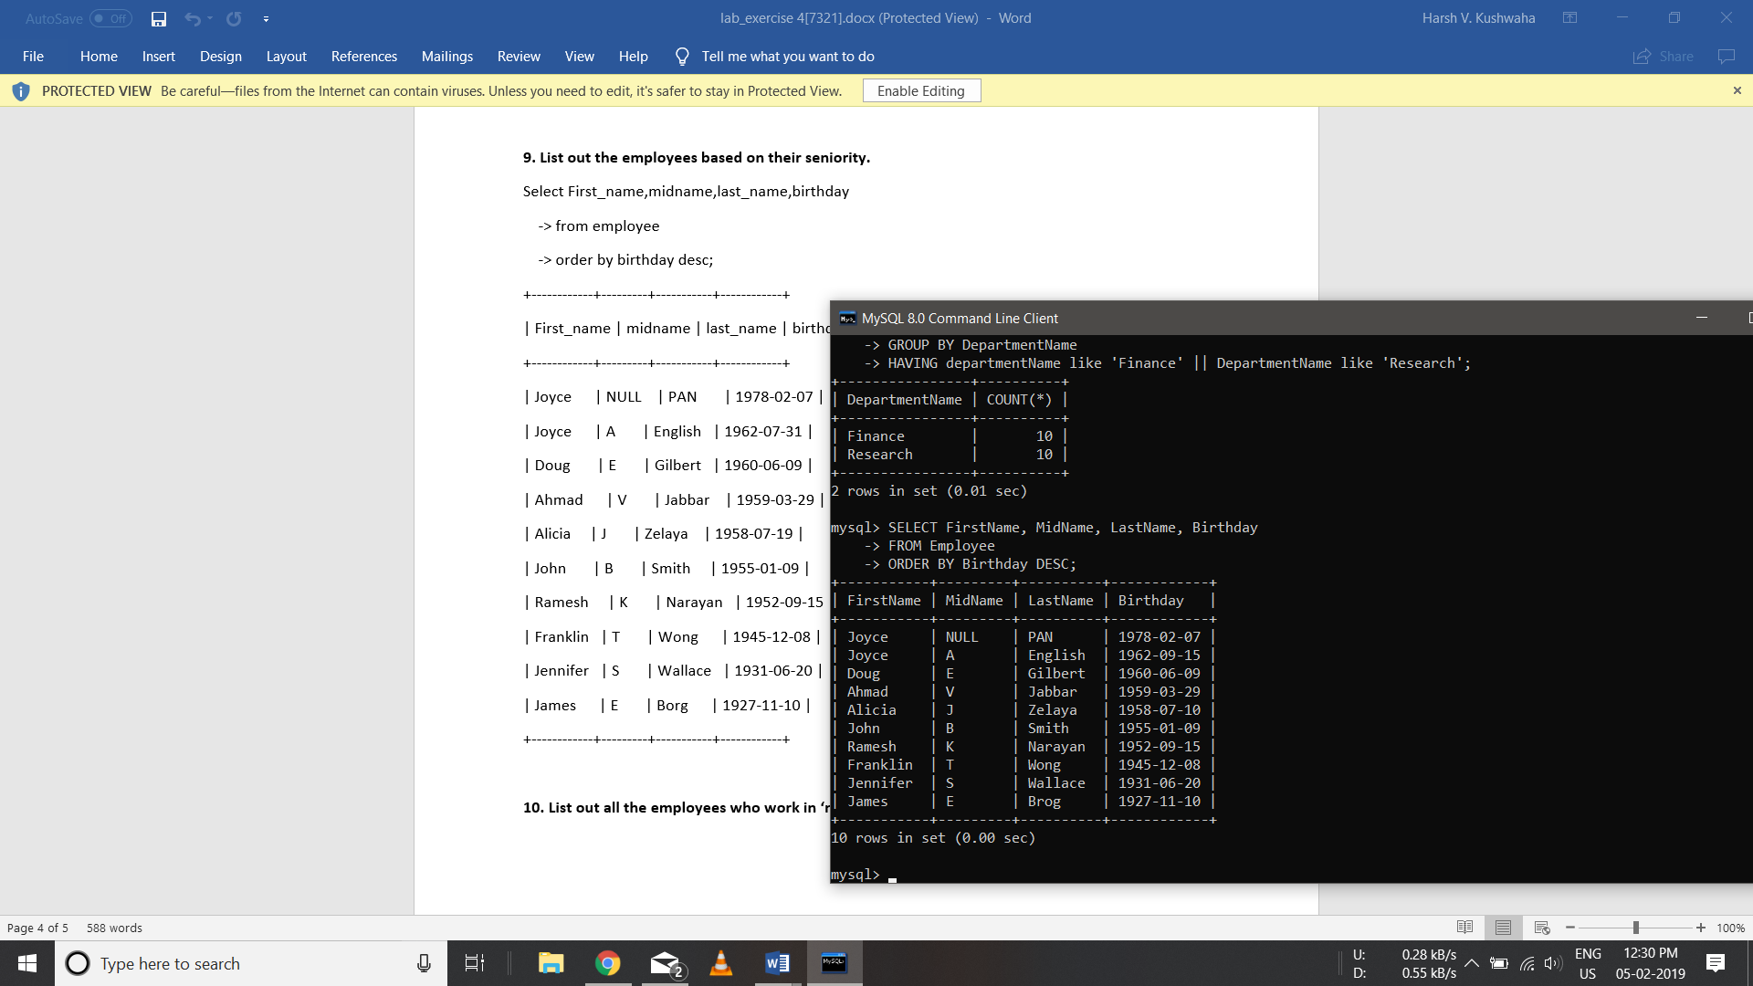

**10. List out all the employees who work in ‘manufacture’ department group by first name.**

